Contract for Services 2024
wendy@sweetbuffetlady.com
14532 169th Drive SE Suite 130, Monroe, WA 98272
425-879-1009 (office/text); 360-217-8722 (fax)
sweetbuffetlady.com

* Required Fields for Reserving Rentals
This is a contract between SBL Rentals by Sweet Buffet Lady and…
* Client Full  Name |  | * Event Date  * Day
Business Name | ----------- | * Secondary Contact  Name
* Client Address |  | * Secondary Contact  Phone
* Client City & Zip |  | * Secondary Contact  E-mail:
* Phone |  | Coordinator/ Planner
* E-mail: |  | Coord. Phone H W C
* Event Name |  | E-mail:
* Venue |  | Venue Address
Venue Contact Person |  | Venue City
* Pickup day  Period Thurs to Mon | CIRCLE  Thursday, Friday, Sat, Sun | * Return date/time | CIRCLE  Sunday or Monday
PICKUP AT SBL  SBL Rentals  14532 169th Dr SE Suite 130  Monroe, WA 98272  ​  M-F: 9am - 6pm  Sat-Sun: 10am-2pm | * Pickup person name:  * Phone:  * Time: | RETURN TO SBL:  SBL Rentals  14532 169th Dr SE Suite 130  Monroe, WA 98272  M-F: 9am - 6pm  Sat-Sun: 10am-2pm | * Return person name:  * Phone:  * Time:

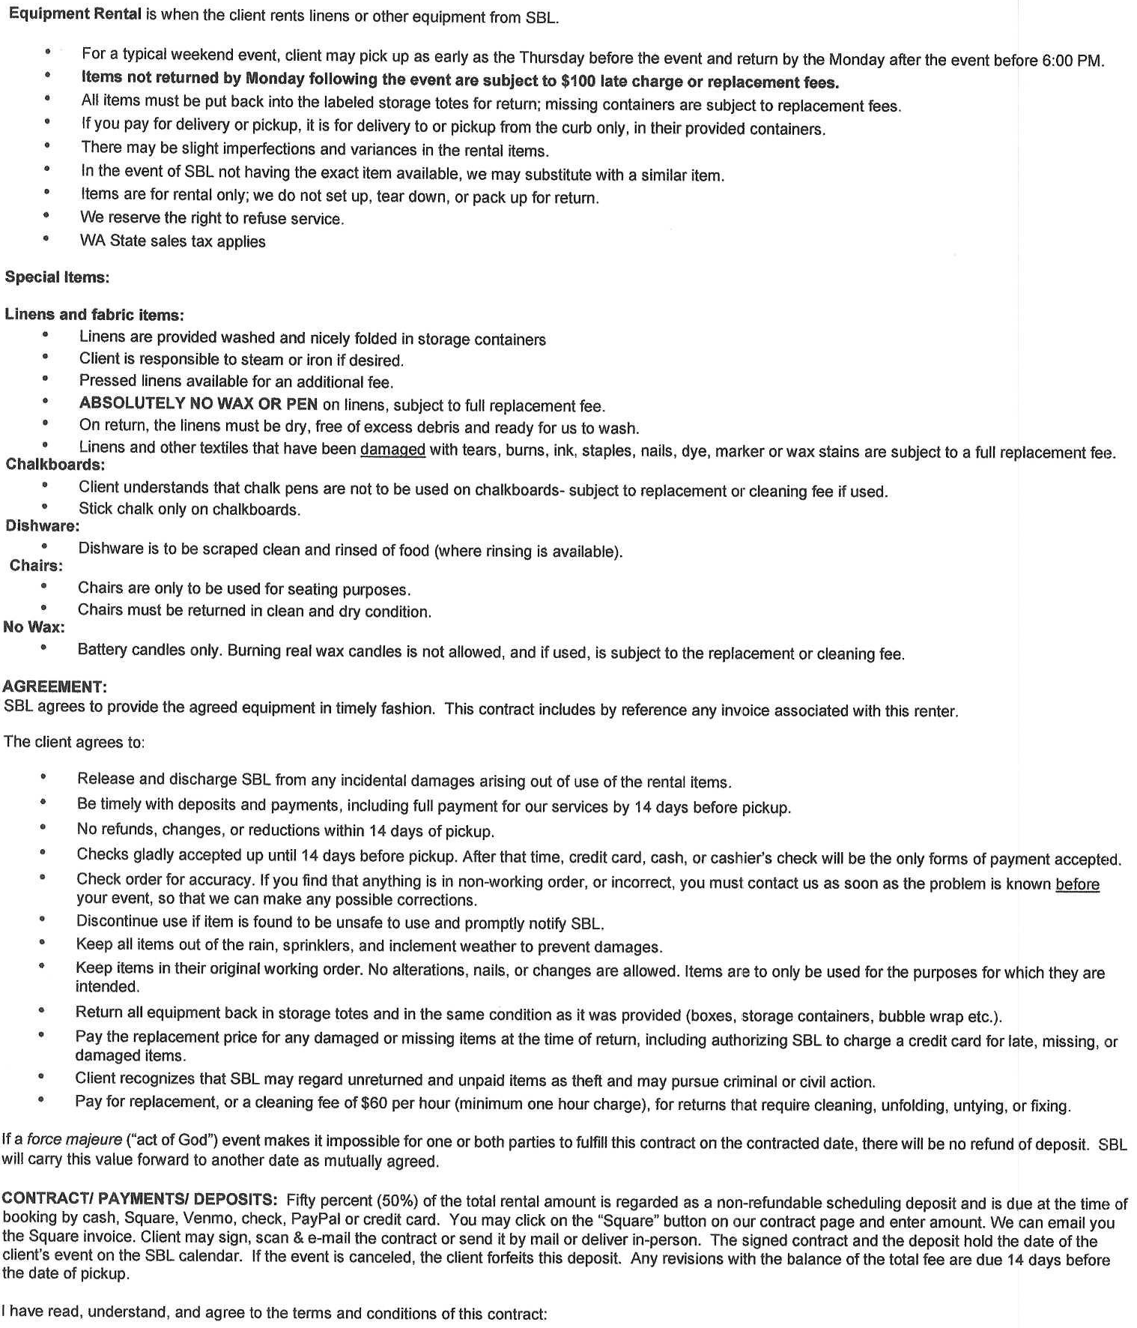
______________________________________________________________________________________________________
Client signature Date
______________________________________________________________________________________________________
Sweet Buffet Lady Date

